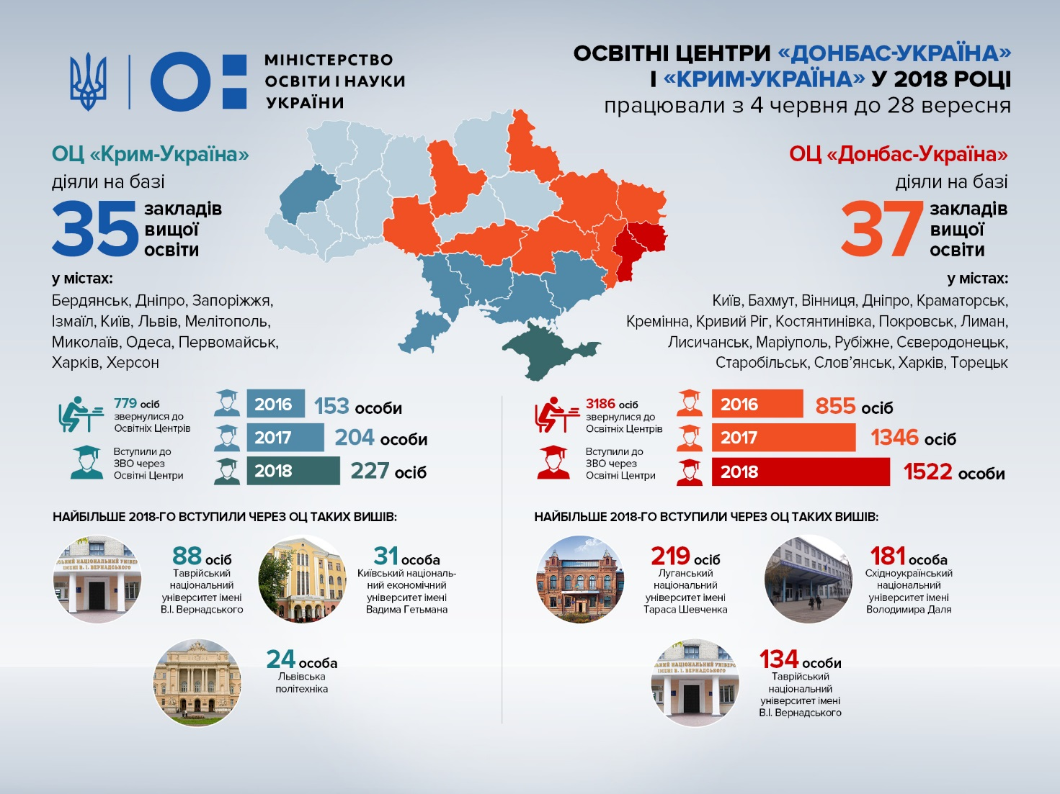
[Електронний ресурс]. — Режим доступу:https://www.google.com/search?biw=1008&bih=636&tbm=isch&sxsrf=ACYBGNRzBc5janbha7ruLpF1oByPcxeLFQ%3A1577371866212&sa=1&ei=2sgEXu3LDPOak74PyIaewAU&q=%D0%9E%D0%A6+%D0%BA%D1%80%D0%B8%D0%BC%D0%A3%D0%BA%D1%80%D0%B0%D0%B8%D0%BD%D0%B0+&oq=%D0%9E%D0%A6+%D0%BA%D1%80%D0%B8%D0%BC%D0%A3%D0%BA%D1%80%D0%B0%D0%B8%D0%BD%D0%B0+&gs_l=img.12...225469.246569..253544...1.0..0.152.1852.2j15......0....1..gws-wiz-img.....10..35i39j0i24j35i362i39j0j0i30j0i10i24.STTthZtxTOc&ved=0ahUKEwjtoI6OyNPmAhVzzcQBHUiDB1gQ4dUDCAc

