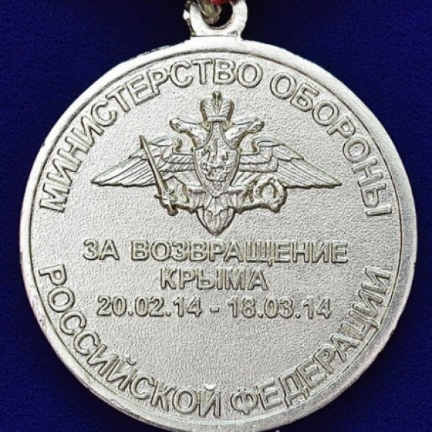
[Електронний ресурс]. — Режим доступу:https://www.google.com/search?q=%D0%BC%D0%B5%D0%B4%D0%B0%D0%BB%D1%8C+%D0%B7%D0%B0+%D0%B2%D0%BE%D0%B7%D0%B2%D1%80%D0%B0%D1%89%D0%B5%D0%BD%D0%B8%D0%B5+%D0%BA%D1%80%D1%8B%D0%BC%D0%B0&sxsrf=ACYBGNSw63A7RE1zCCCM6enKxj-uh9SBKQ:1577371862774&source=lnms&tbm=isch&sa=X&ved=2ahUKEwjzuryMyNPmAhULrosKHdOvACEQ_AUoAXoECBAQAw&biw=1008&bih=636

